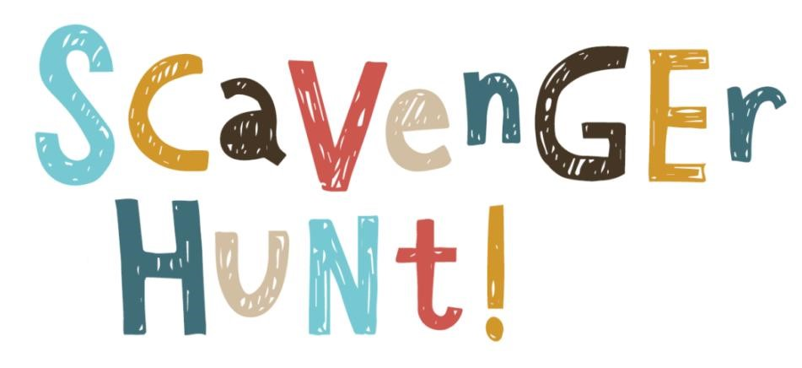
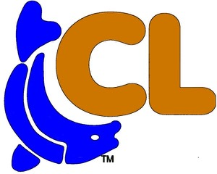
Mark on the checklist below all the things you see on your adventure walk #7
Anchor
Windmill
Seahorse
Sail Boat
Star
Mermaid
Flamingo
Eagle
Water Ski
Colorful Fish

Adventure Walking Path #7
Round Trip Walk 1.4 Miles

