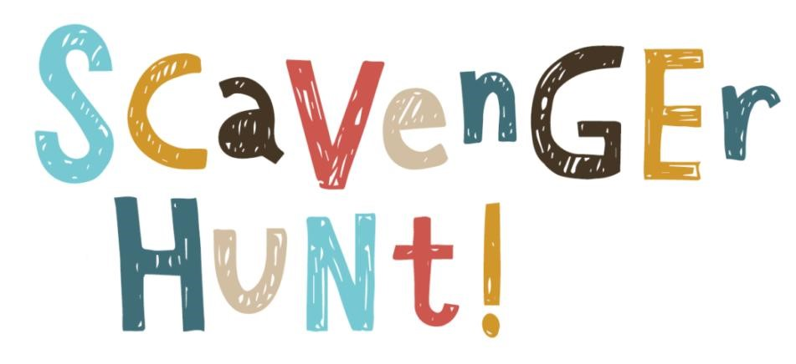
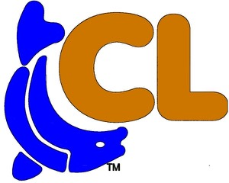
Mark on the checklist below all the things you see on your adventure walk #5
Eagles
Crane
Kayak
Orange Canopy
Gazebo
Butterfly
Boat Helm
Railroad Crossing Sign
Compass
Chicken Coop

Adventure Walking Path #5
Round Trip Walk 2.5 Miles

