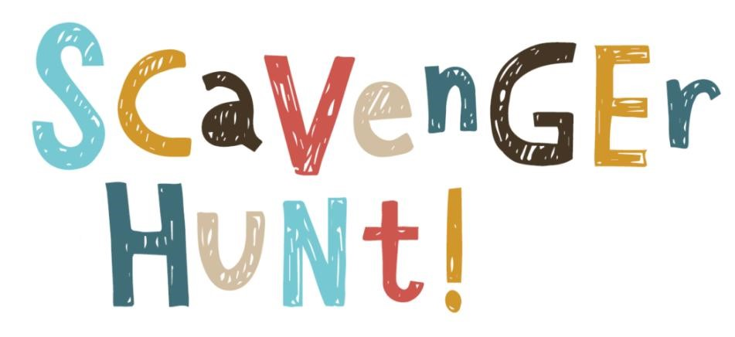
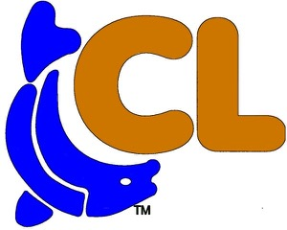
Mark on the checklist below all the things you see on your adventure walk #2
Four Owls
Fish on a Fishing Rod
Horse Head on a Pole
Boat Helm
Canadian Goose
Railroad Crossing Sign & Lights
American Flag on Flagpole
Water Ski
Basketball Hoop
Yellow Flower

Adventure Walking Path #2
Round Trip Walk 2.3 Miles

