Mark on the checklist below all the things you see on your adventure walk #1
Mommy and Baby Bear
Turtle
Butterfly
Boat
Firewood
Fisherman in Yellow Coat
Boat Helm
Golf Cart
Bunny Rabbit
Bird in a Tree

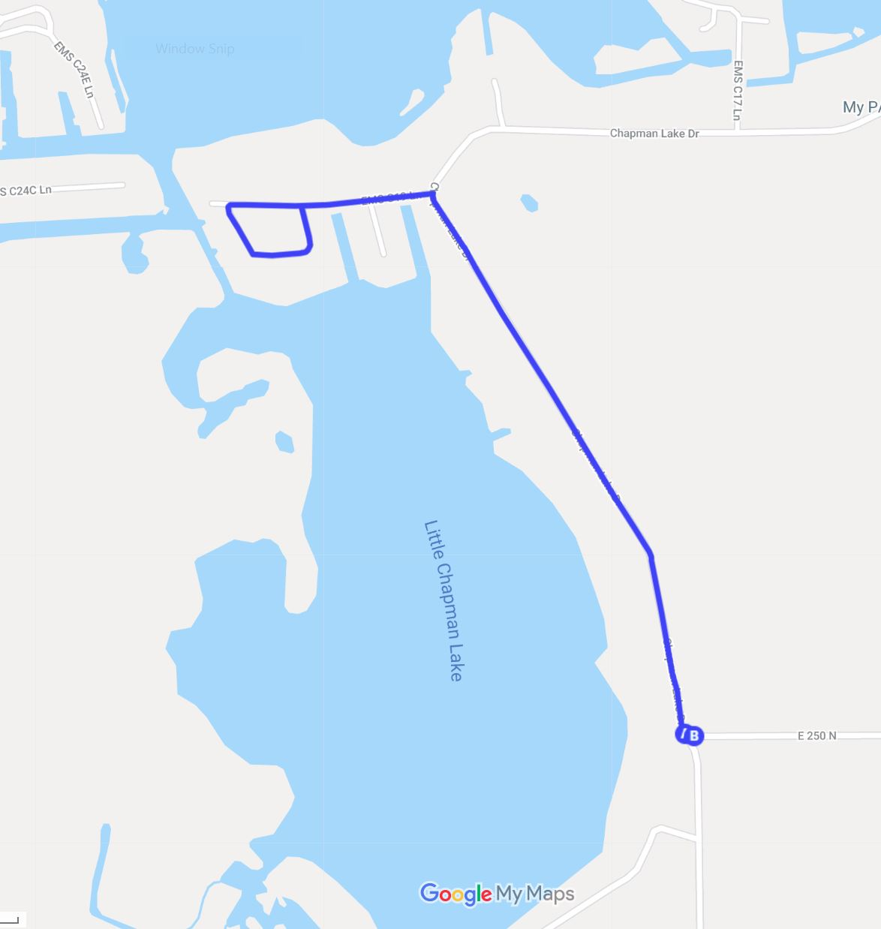
Adventure Walking Path #1
Round Trip Walk 1.7 Miles

